**COMP9032 Project Design Manual**

Name: Weijia Min zID:5228412

1. **Introduction**

Smart Airplane Window Controller is a digital window control system, compared with tradition manual window controller, it can provide convenient services to the passengers. By pressing the buttons, the passengers can freely control the window shadow, what’s more, with the help of centralized and emergency control, the flight crew can easily control the state of all window shadows.

1. **Board Settings**



1. **Components Information**



1. **Control Procedure**

After the initialization of Smart Airplane Window Controller, the LCD will display the initial state and the opaque level of each window.



After that the passengers can individually control their own window to meet their requirements. The state will become ‘L’ means local control, and the opaque level of each window will change according to passengers’ operations. In this system, these operations are based on the keypad, additionally, the max opaque level is 3, passengers can only change the level from 0 to 3, the higher the number is, the darker the window will be.



During the process of takeoff and landing, the window shadow should be opened, in the case, a central control system is designed. By using the control system flight crew can easily manage passengers. When the window is set to dart by central control, the state in LCD will become ‘C’, which means central control, and all windows’ opaque level change to 3. In the state, the local control becomes invalid, until the central control set all windows clear, passengers can control their own windows again.

(LEFT is central control ON / RIGHT is central control OFF )

 

In order to handle emergency, an emergency control is designed. After pressing the emergency button, the state in LCD will become ‘!!’， which means emergency and all windows are set to clear. After that, the local and central control will become invalid, until the whole system is reset.

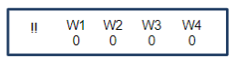

1. **Design flow chart**
2. Overall process

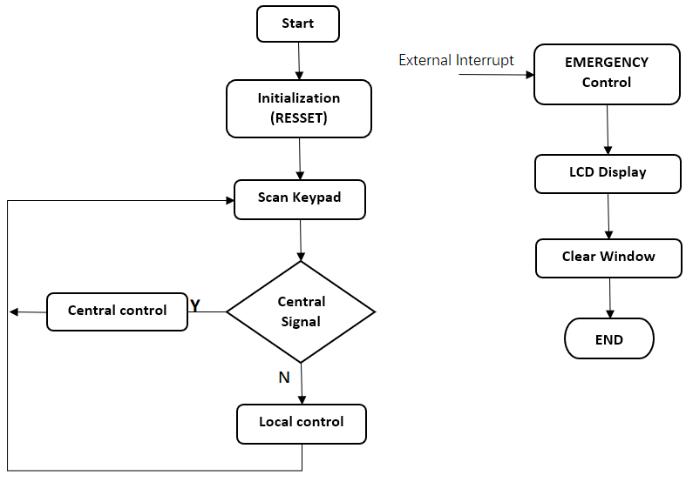

1. Local & Central control process

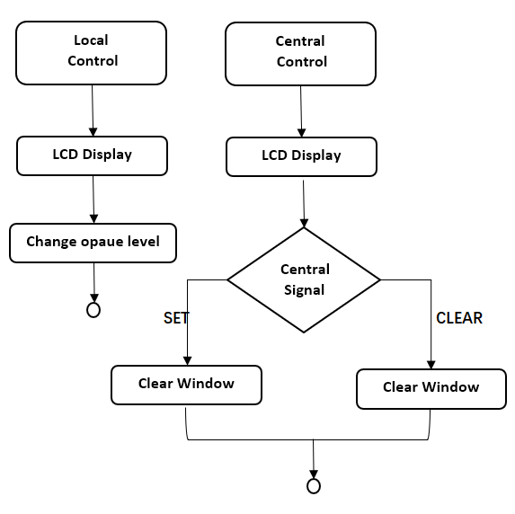

**6.Design Detail**

1. Opaque Level

The opaque level of windows is related with the PWM, by modifying the PWM duty cycle, the opaque level will change higher or lower accordingly. And the PWM signal is generated by the TIMER, in the case, there are four windows, each of the windows is controlled by different TIMER.

In local control, the passengers can change opaque level by modifying their own TIMER’s PWM duty cycle.

In central and emergency control, these two controllers change opaque level by modifying all TIMER’s PWM duty cycle

1. Control priority

According to the assignment specification, the emergency control has the highest priority, so it is designed as a external interrupt, once the emergency control button is pressed, the interrupt will take the system process and end the whole system,

The central control is realized by using a signal register, once the signal register is set, the system will ignore local control request. And when central control is off, the signal register will be clear, and the system will receive the local control request again.